**Final Sprint Requirements Artifacts**

1. Add ability to remove followers (Requirement-ID 16) 5 Story points
2. Set difficulty of tic-tac-toe bot (Requirement-ID 20) 8 Story points
3. Add ability to unfollow other users (Requirement-ID 24) 8 Story points
4. Send notifications on likes on a post (Requirement-ID 25) 8 Story points
5. Ability for users to matchmake to play random players (Requirement-ID 26) 8 Story points
6. Add a dashboard for each player with number of wins, losses and ties (Requirement-ID 27) 3 Story points
7. Add a friend system for easy game invites and messaging (Requirement-ID 29) 8 Story points
8. Implement achievements and badges for milestones (Requirement-ID 31) 5 Story points
9. Show user status (online, in-game, offline, etc.) (Requirement-ID 32) 3 Story points

56 Total Story points

1. Add ability to remove followers (Requirement-ID 16)

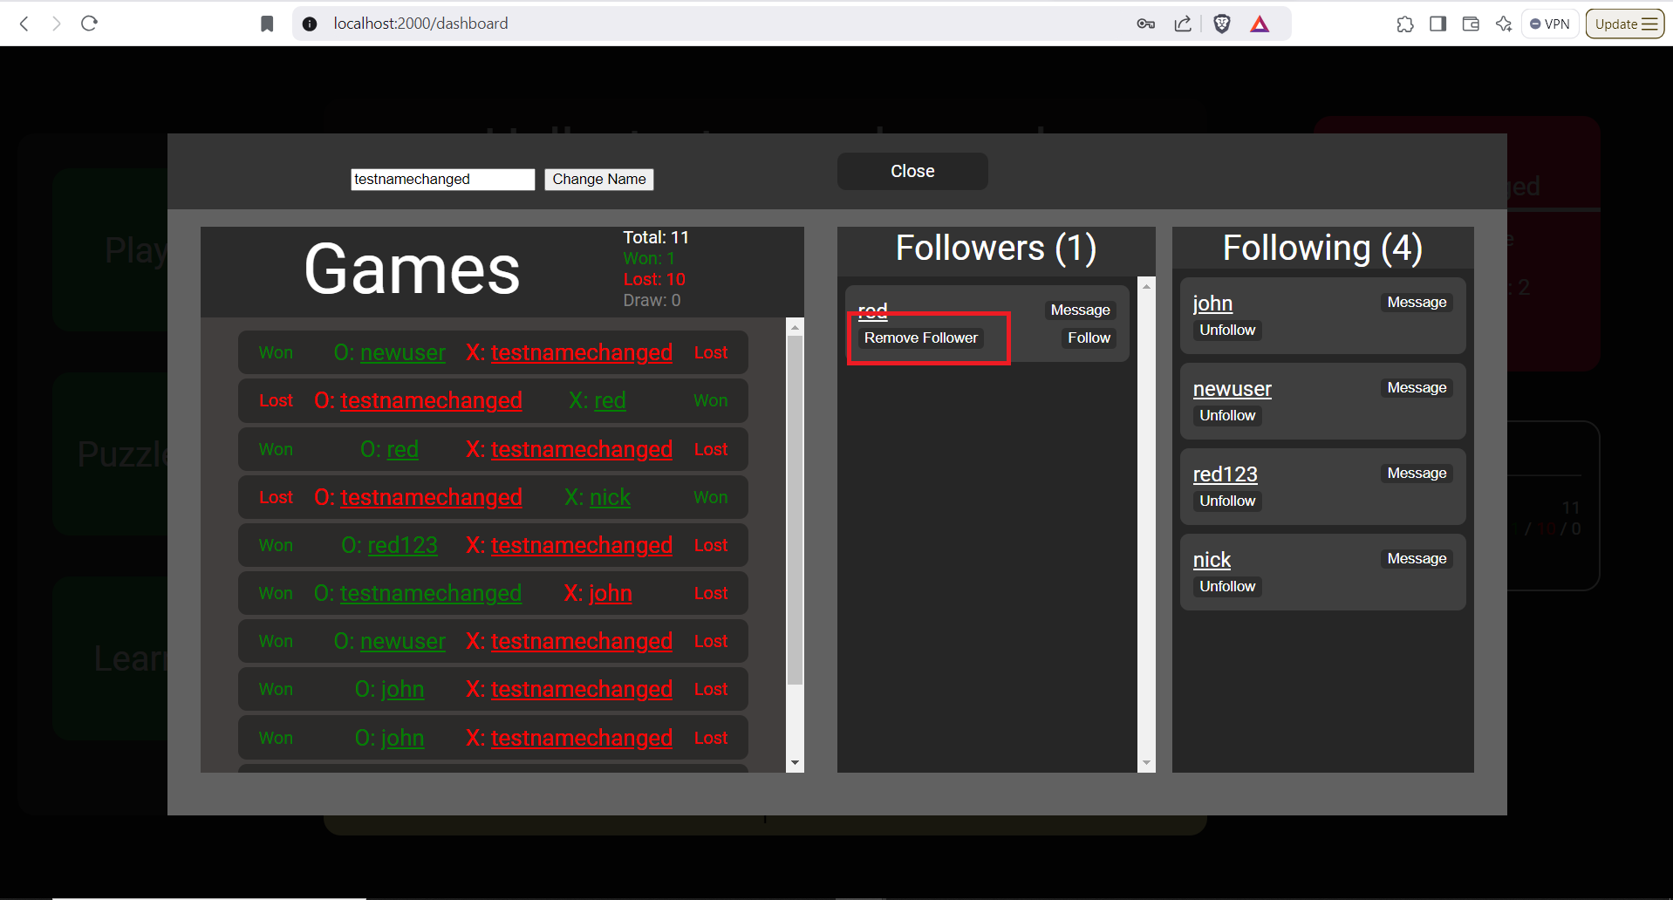

1. Set difficulty of tic-tac-toe bot (Requirement-ID 20)
   1. Users want to be able to change the difficulty of the tic-tac-toe bot.
   2. Users want multiple levels of the difficulty of the bot.
   3. Users want bot with adaptive level of difficulty as game continues.
2. Add ability to unfollow other users (Requirement-ID 24)

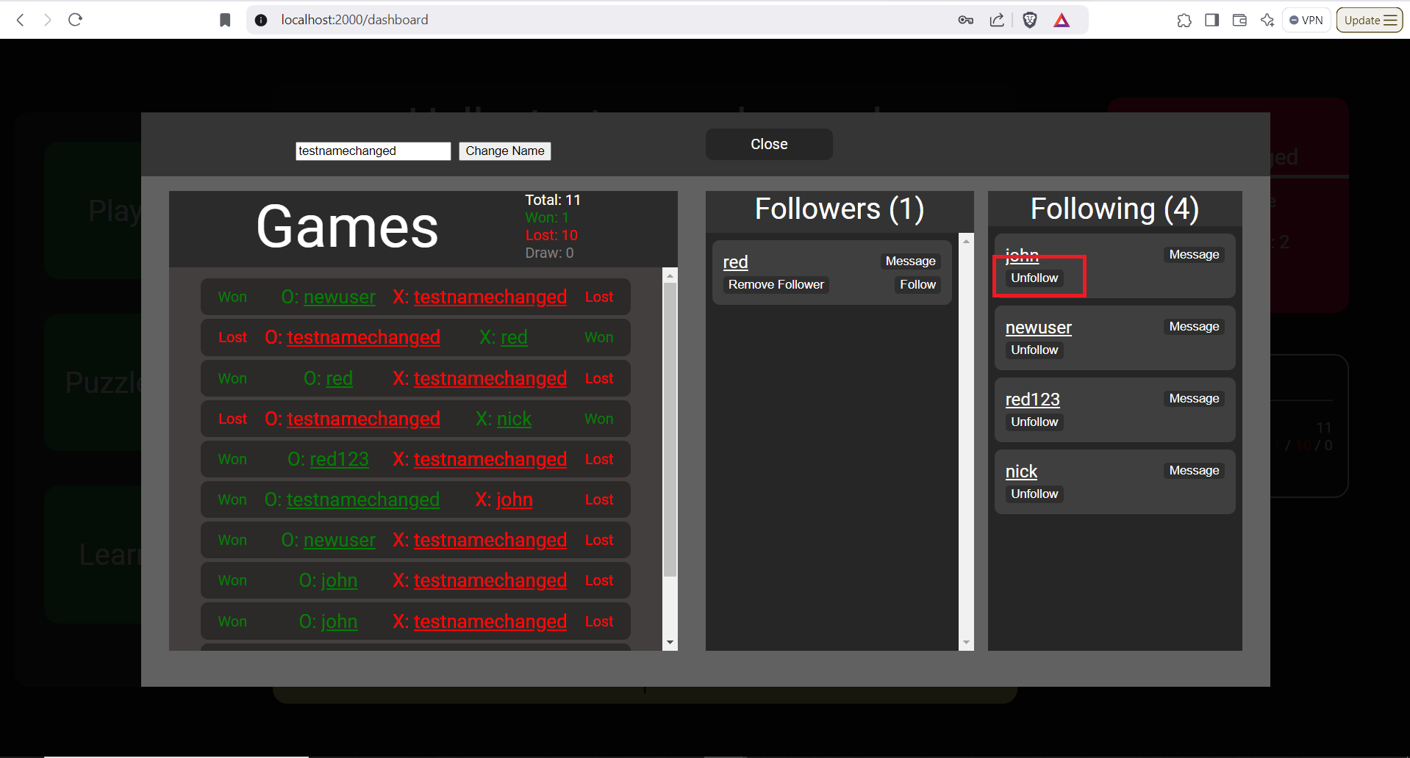

1. Send notifications on likes on a post (Requirement-ID 25)

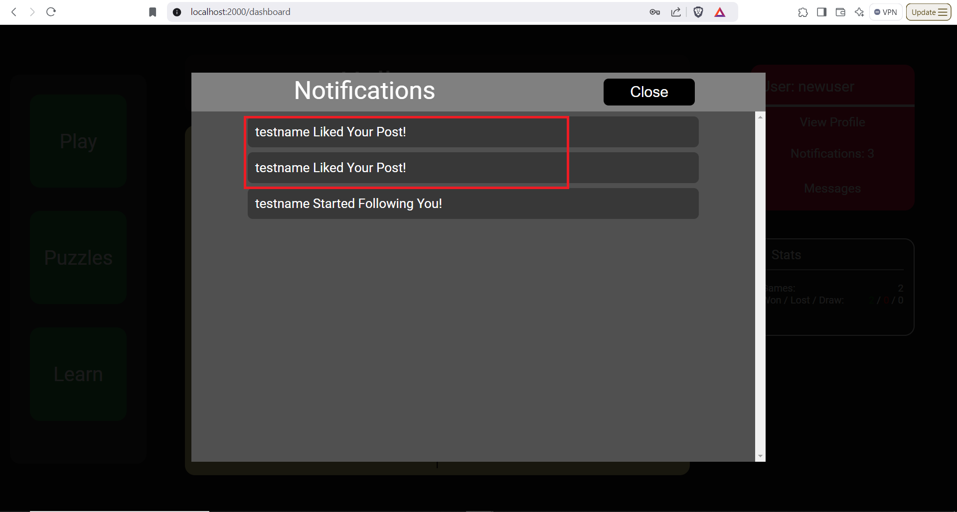

1. Ability for users to matchmake to play random players (Requirement-ID 26)
   1. Current matchmaking joins users based on their precedence (rather than being truly random).
   2. Users want a more “random” procedure for matchmaking.
   3. Users want to play against similarly scored users.
2. Add a dashboard for each player with number of wins, losses and ties (Requirement-ID 27)

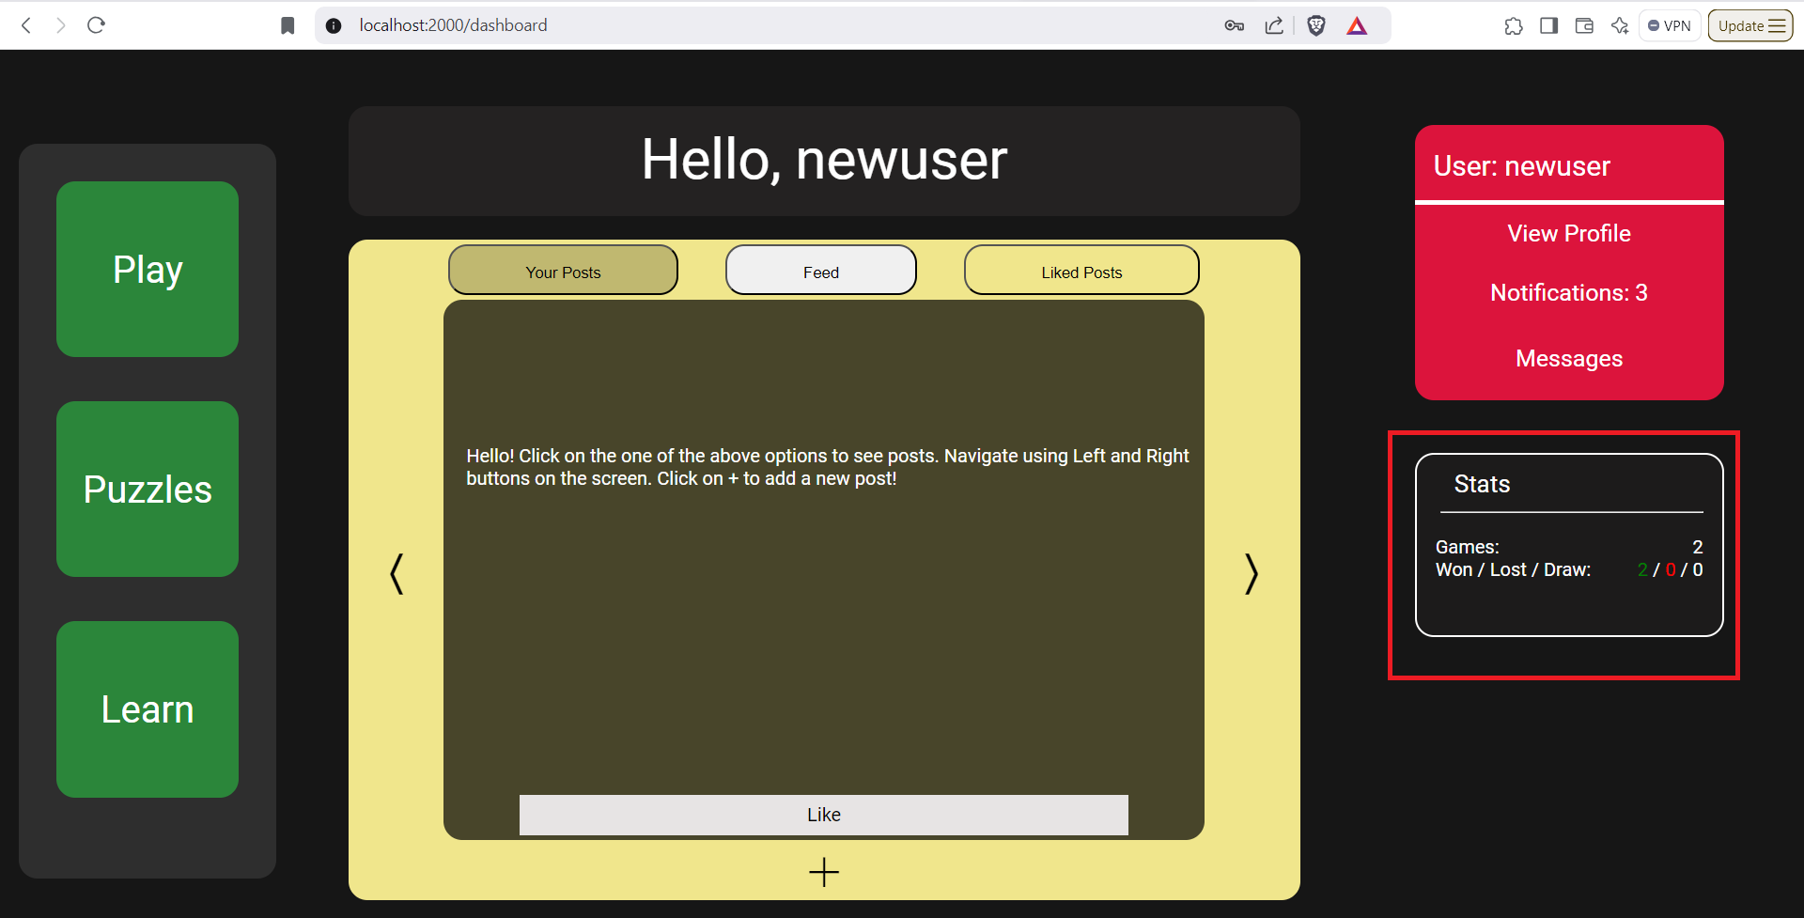

1. Add a friend system for easy game invites and messaging (Requirement-ID 29)
   1. Currently, there is no easy way to discover other users.
   2. Customers want a simple way to discover other users by their user name.
   3. Customers optionally want a way to search based on email address.
   4. Customers optionally want an auto-complete for the user combo box.
   5. Customers optionally want fuzzy searching.
   6. Customers want a way to invite others to view their profile.
2. Implement achievements and badges for milestones (Requirement-ID 31)
   1. Customers want to see their achievements (For instance: 3-day win streaks, among top 1% of players, among top 10% of players, moves which bot will perform).
   2. Customers want to see badges (For instance: “I’m new here”, “Playing since 2020”, “Most wins via diagonal”).
3. Show user status (online, in-game, offline, etc.) (Requirement-ID 32)
   1. Customers want to see when other users are online to invite and chat.
   2. Customers want a green/red marker next to users, indicating when they are online.